**DFD for FOOD COURT AUTOMATION SYSTEM**

**Level 0**

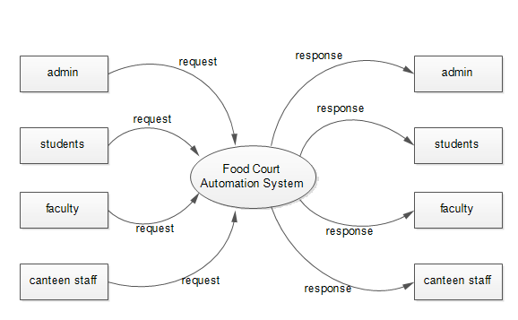

**Level 1 dfd for Admin**

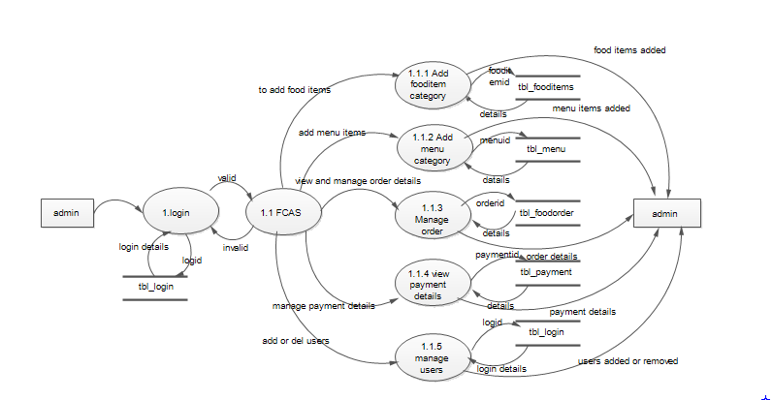

**Level 1 dfd for User**

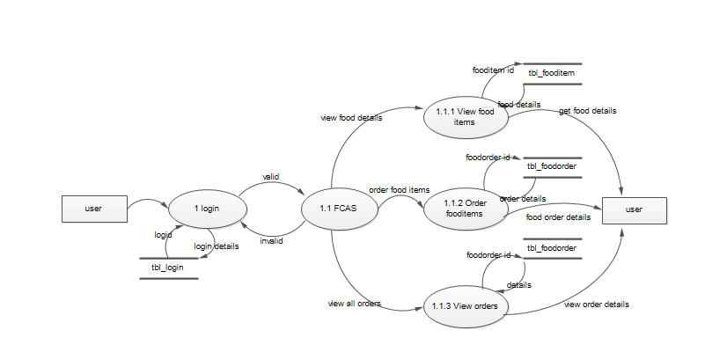

**Level 1 dfd for Canteenstaff**

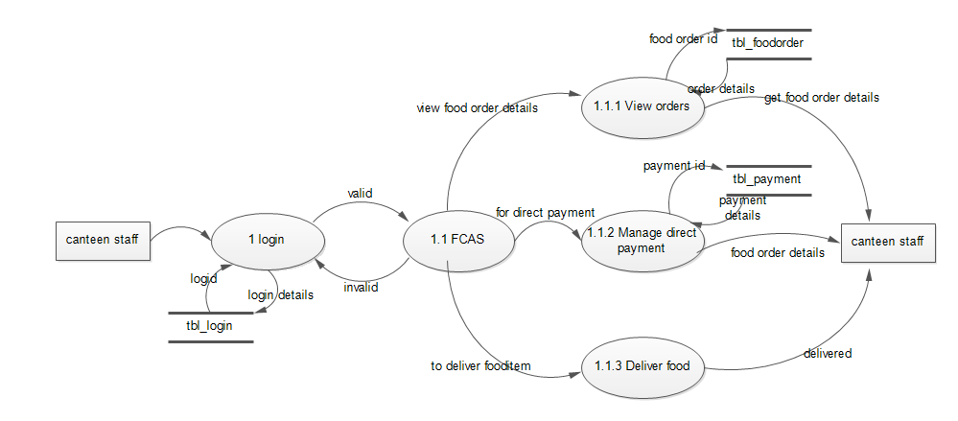

**Level 2 dfd Admin Add food item**

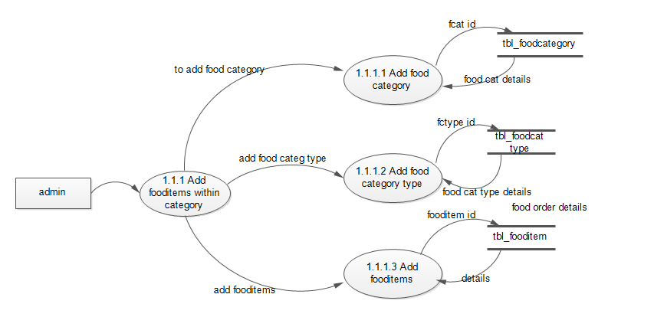

**Level 2 dfd Admin Add menu**

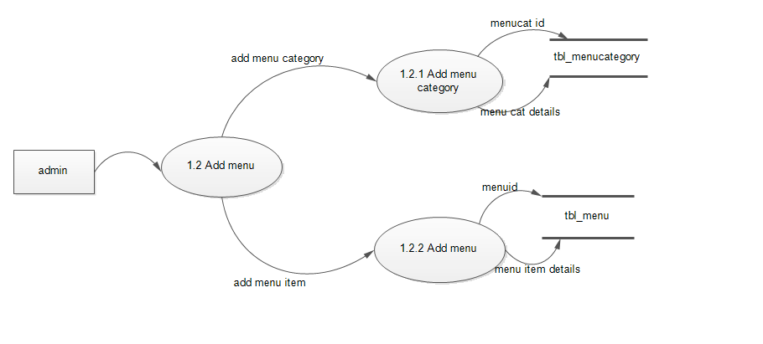

**Level 2 dfd User Order food item**

